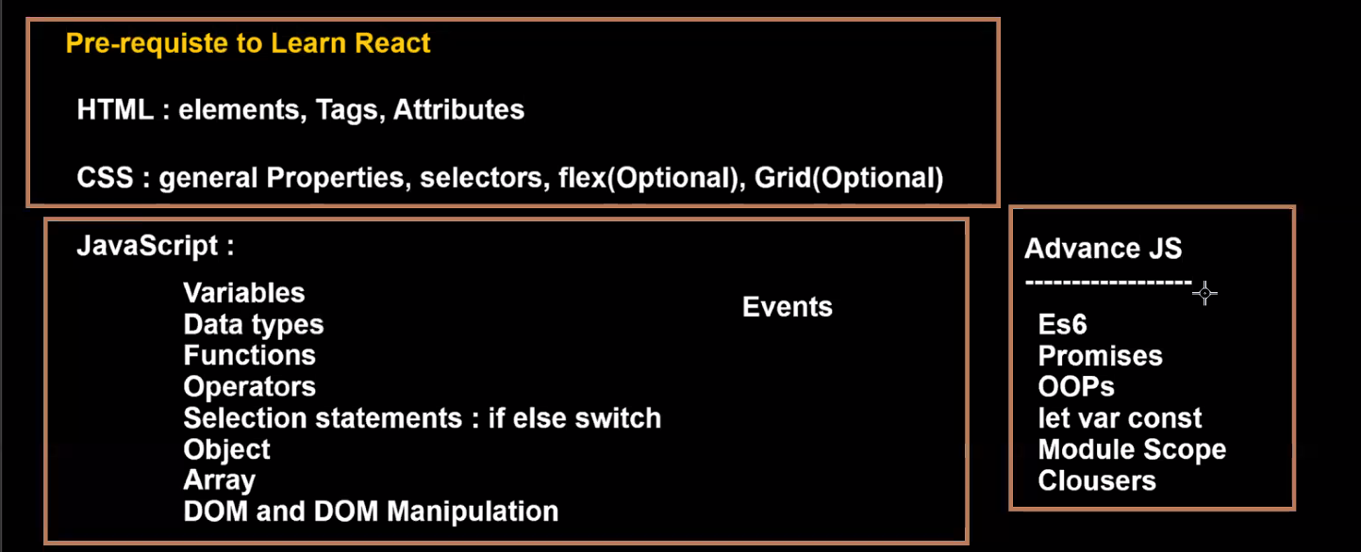

React is a Library.React is not a framework.

A library is a collection of predefined classes, functions, objects. The library is created using JavaScript language.

React JS is a JavaScript library.

What is the purpose of React JS?

React JS is used to create User Interface.Creating User Interface is only just one part of Front end application.

Using React we can create static User Interface and dynamic UI.

Using only React we cannot create a Front end application.

To create Front end , along with React we have to use some additional libraries.

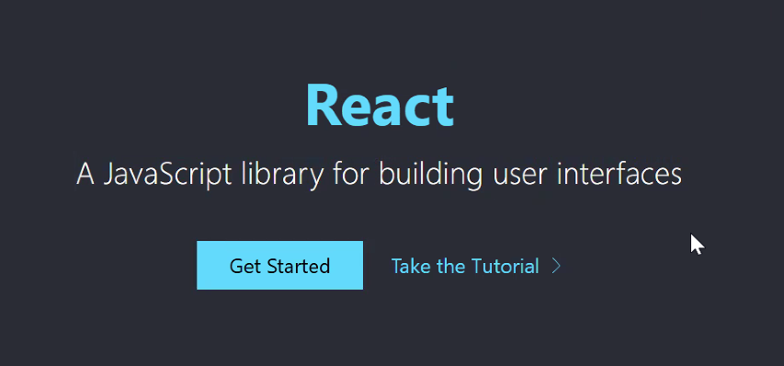

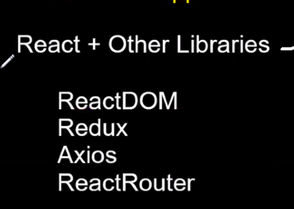

<https://legacy.reactjs.org/> --- old documentation

<https://react.dev/blog/2023/03/16/introducing-react-dev> -- new documentation

Along with React the above libraries are used to create Front end application .

Version 18 is the latest version of React.

**Official website for React**

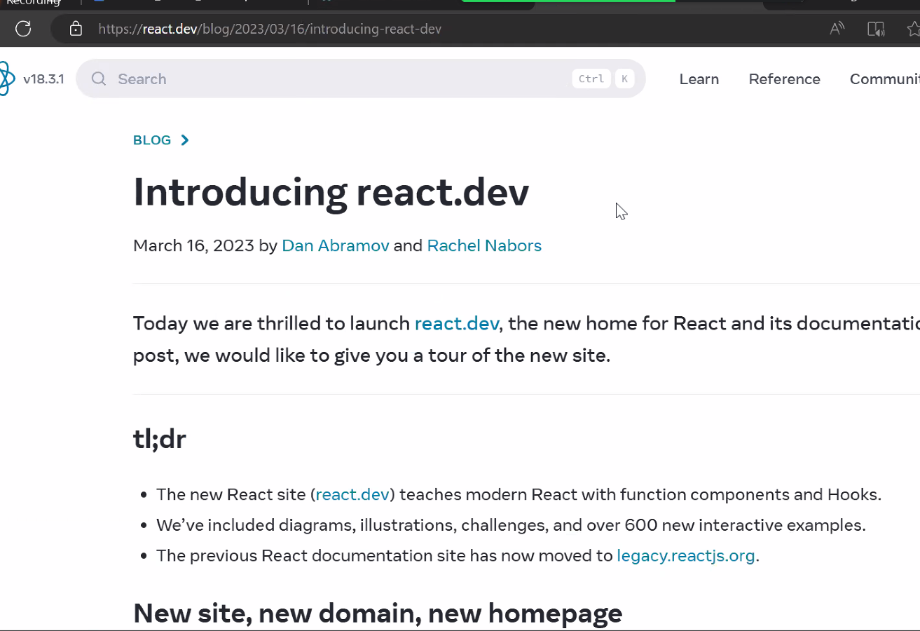

**Interview question**

**When you already have HTML and Java script to develop User Interface, why are we using React again?**

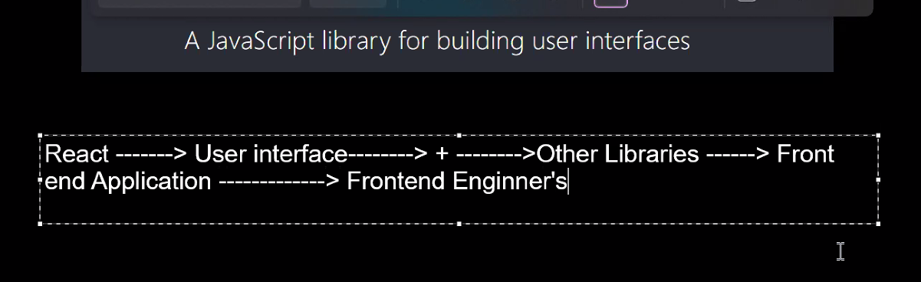

React is used to build or create User Interface

User Interface is a collection of UI components.

By using HTML also, you can create UI.Using JavaScript also we can create User Interface.

Then again why are we learning React to create UI?

Create a simple Button using HTML

HTML provides Button Element --Button Tag

Create a simple Button using JavaScript

JavaScript provides some predefined objects and functions.Using those predefined functions and objects we can create DOM Button Element.and add that DOM Button Element to DOM.

To create any DOM element in Javascript, we have to use document.createElement(‘button’)

If you create button using HTML, you call it HTML button element.

If you create button using JavaScript, you call it using DOM button element

In Javascript, using which method we can create a button?

We can create a button in HTML using only one line of code.

We can create a button in Javascript , we have three lines of code

Therefore, creating a button in HTML is easier compared to JavaScript.

In HTML, we rewrite the code . For example if we want to create alist of names and display it 4 times on UI, we rewrite HTML code 4 times.

Where as in Java script we write the code in a function and we call the function 4 times

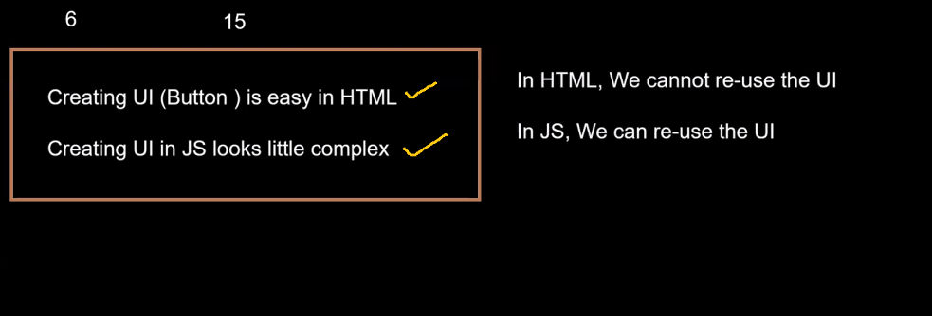

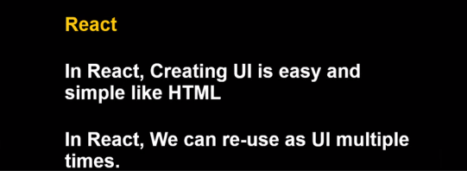

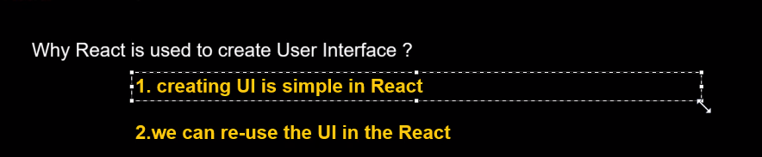

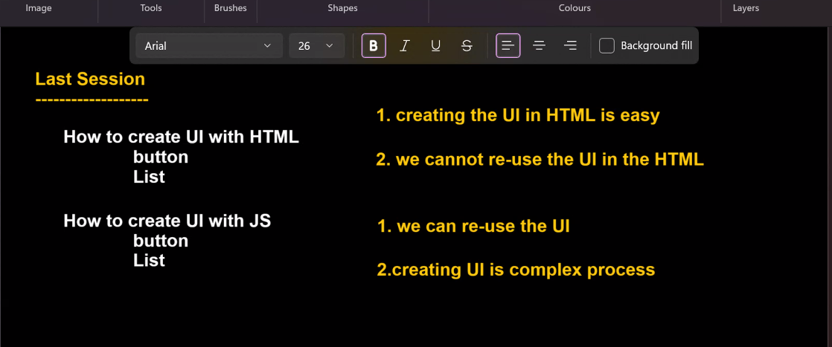

**SESSION-3**

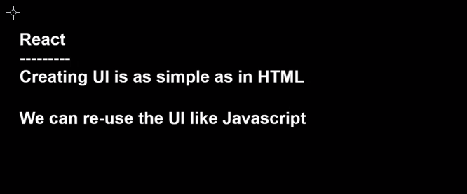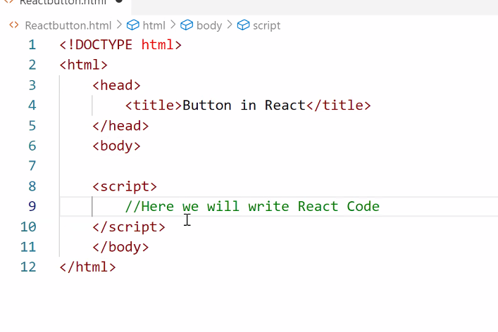

Inside the script tag, we will write REACT code

**Integrate REACT JS with HTML document**

To connect Javascript file to HTML file, we will use SCRIPT tag and give src=path of JS inside HTML file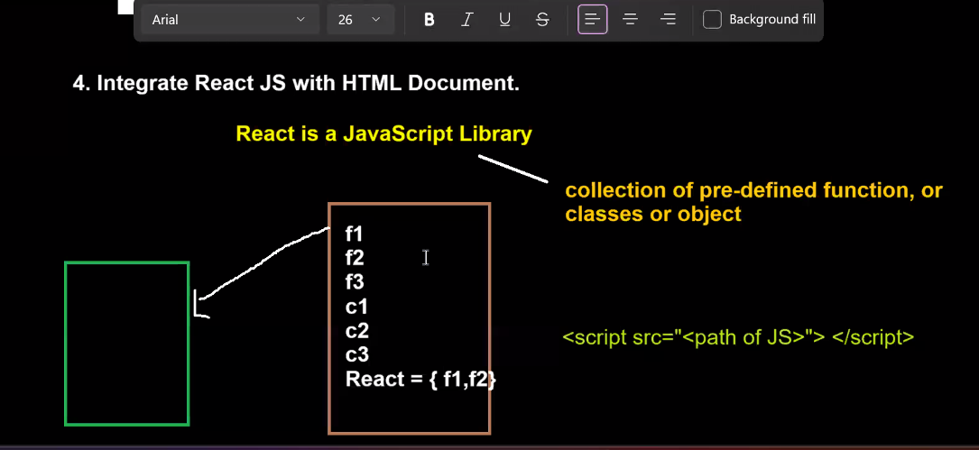

To get the link, go to **<https://legacy.reactjs.org/>**

On the right side, click on CDN links.

Copy the first link

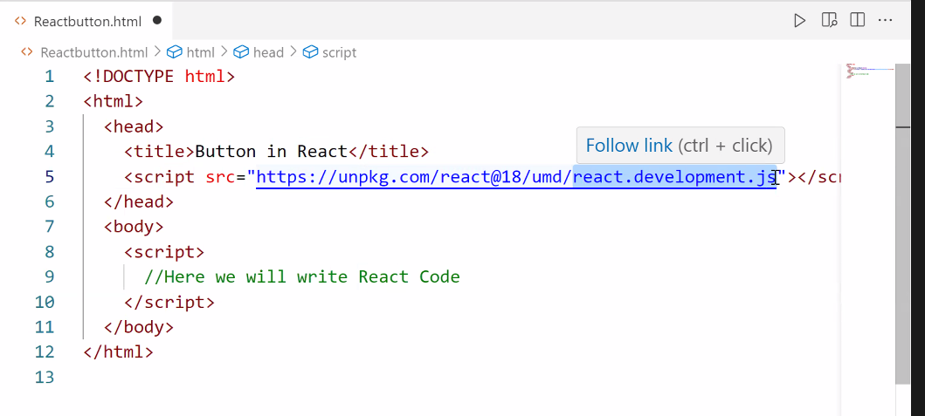

HTML is providing HTML elements to create UI

JS is providing pre-defined object and functions to create DOM elements. REACT elemets are very similar to DOM elements.Add them to DOM.

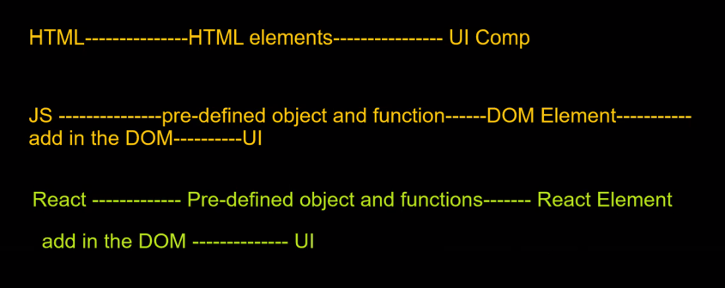

Childrens are something present in between opening tag and closing tag

In the above pic, for HTML tag---head, title, script are children

“Button in React” is child for <t>

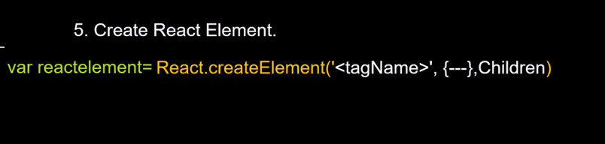

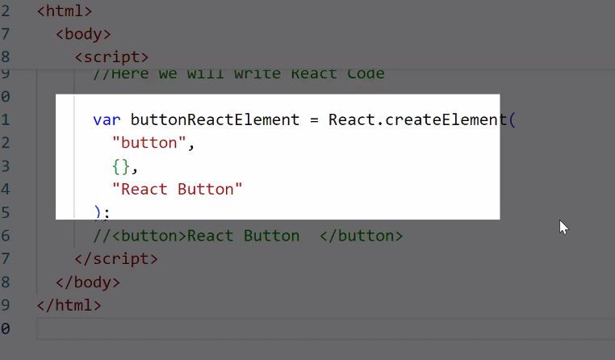

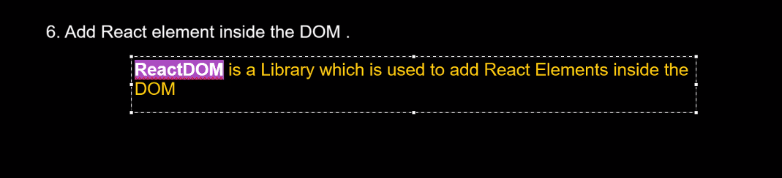

Integration of REACT DOM with HTML document

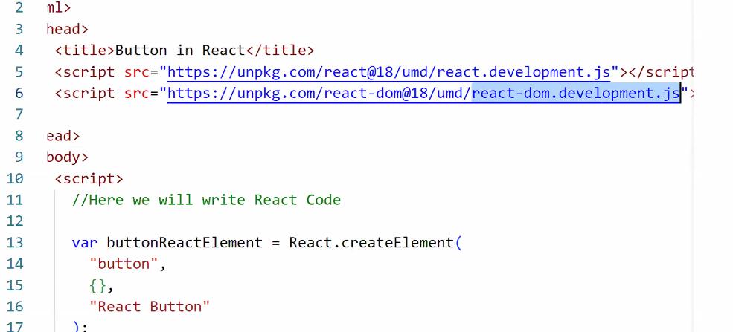

When you want to add React element inside the DOM, you have to integrate ReactDOM with HTML document.

As mentioned earlier, using React you can only create button.To add it to DOM, you need additional libraries.

React library: To create elements

React DOM: To add elements to DOM.

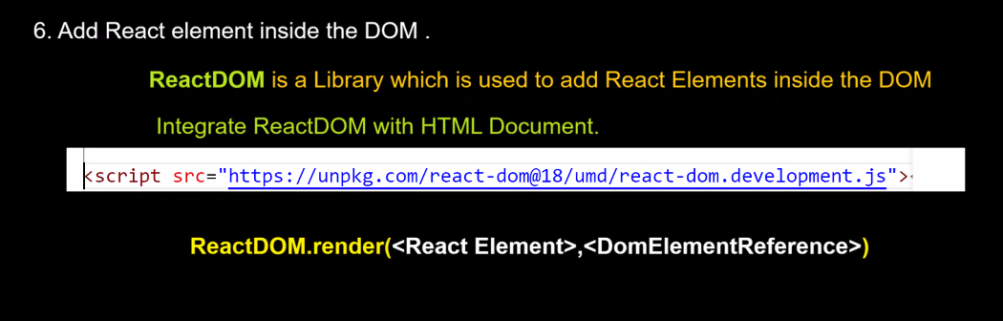

DomElementReference: In your React, where you want to add the react element.

ReactDOM.render(buttonReactElement,document.getElementById(‘body’))

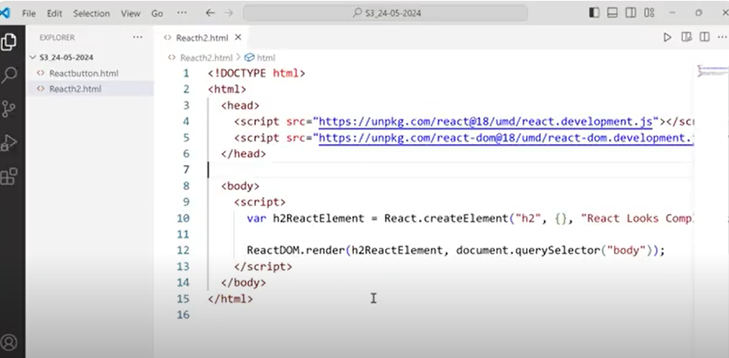

**Creating UI in REACT is simple or complex?**

JSX--- Javascript and XML

Babel compilers convert JSX elements to REACT elements.

Then REACT elements will be given to ReactDOM and ReactDOM will add it to DOM

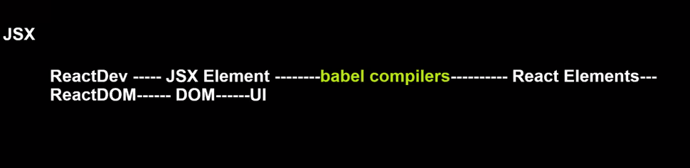

Instead of creating REACT elements, we create JSX elements and JSX elements are 95% similar to HTML elements

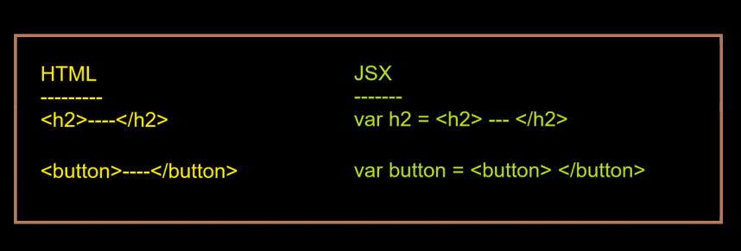

Due to JSX, creating UI in REACT became very easy

**SESSION 4**

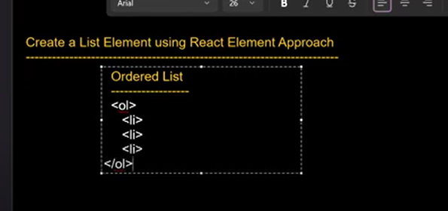

**How to configure the attributes in React elements?**

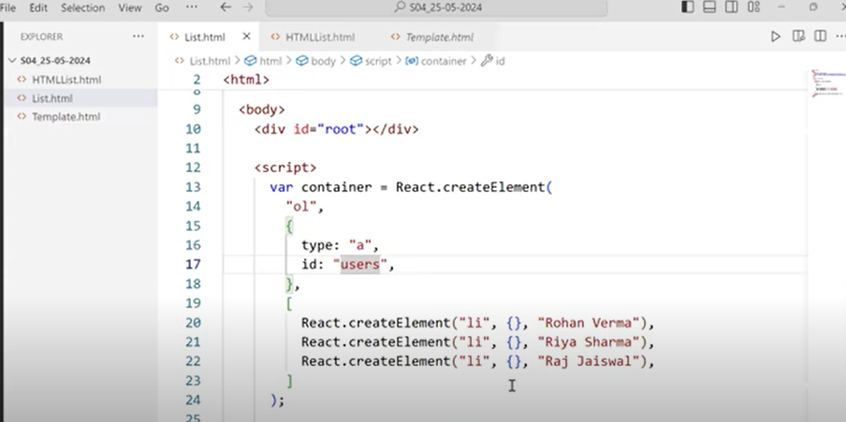

**How to add inline CSS in React?**

In React, whenever you are using Style attribute,its value should be one object.

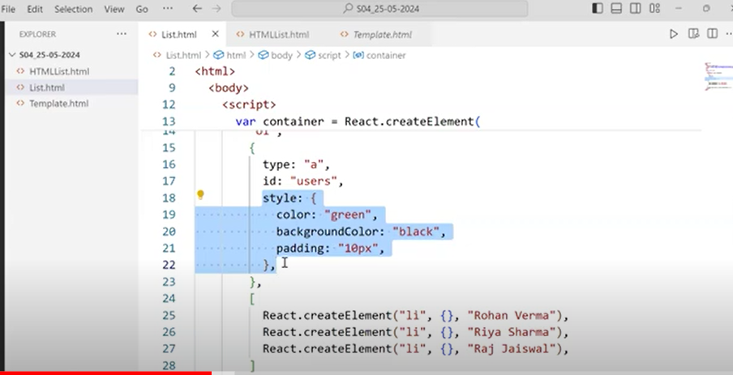

As a developer, we are creating ReactElements uisng React and then adding those React Elements to DOM using ReactDOM and UI is created.

This process looks complex.

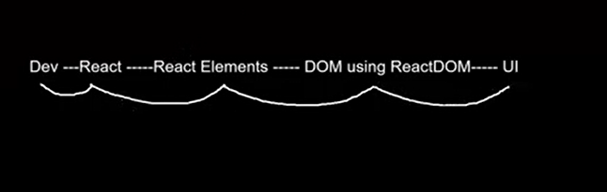

To make it easy, we started a new approach

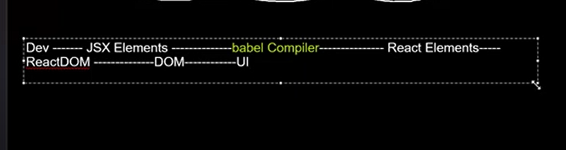

JSX elements are very much similar to React elements and babel compiler converts JSX elements to React elements.

**How to create button with JSX?**

Along with REACT and REACTDOM, we will also integrate BABEL with HTML document.

Go to this link:  **<https://babeljs.io/>**

Click on **SetUp** and click on **In the Browser.**

Scroll down and copy the script tag

<https://unpkg.com/@babel/standalone/babel.min.js>

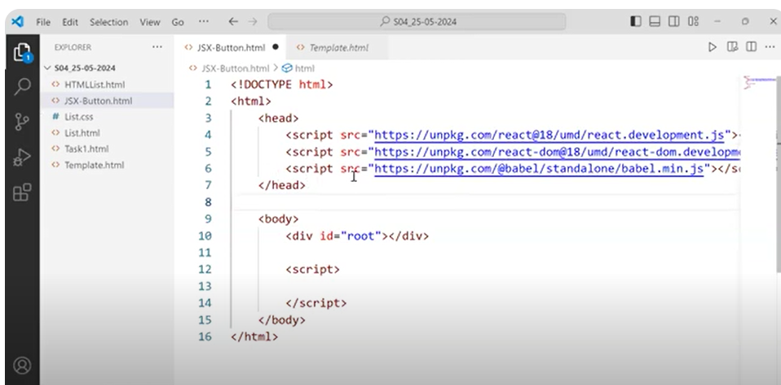

Add type =”text/babel” in script tag

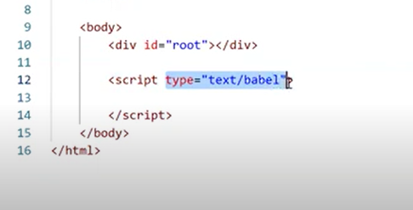

Inside your script tag, if we you are writing any HTML code, then it is called JSX.

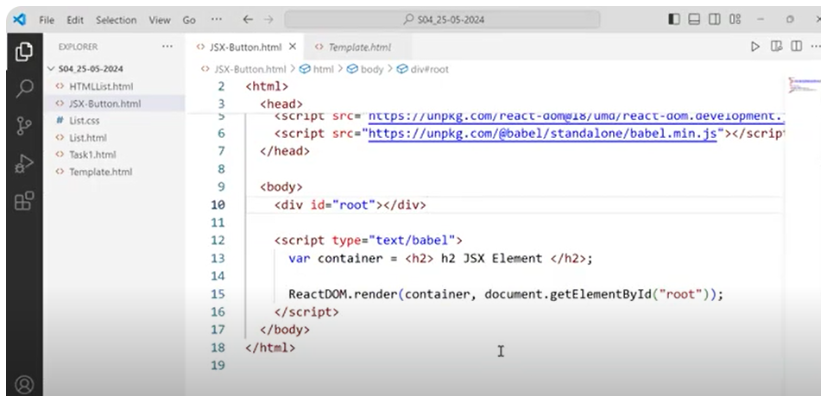

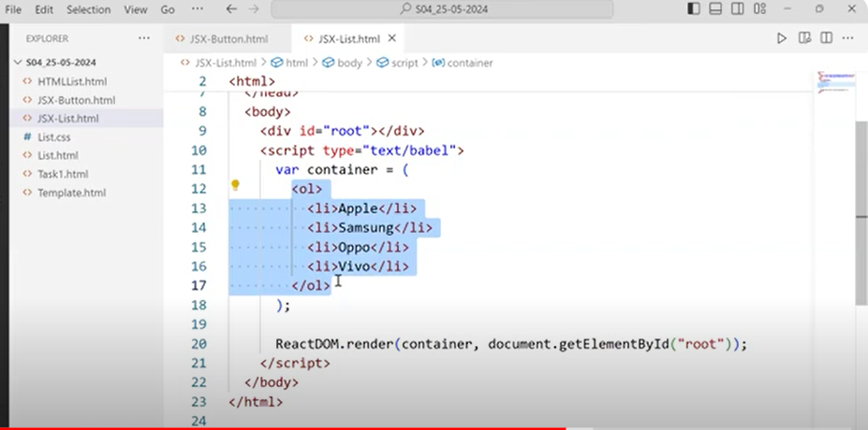

Add marker ‘a’

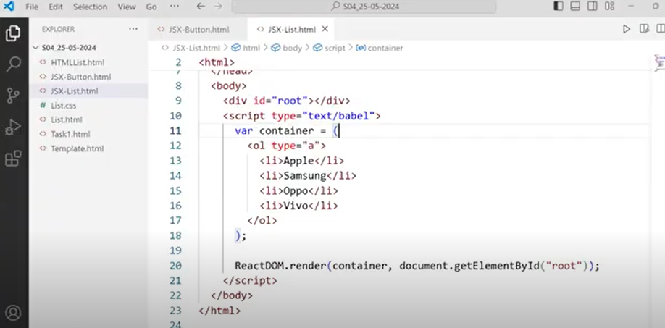

Just for developers convenience, we are writing UI code in JSX.But at the end, JSX code should get converted to REACT elements and BABLE will take care of that.

**SESSION-5**

**Default width and height of div is**

**Width: 100%-- by default width occupies full screen**

**Height: Depends on children**

In order to make div look like a card, decrease width of div to some value and increase height of div to some value.

We can add CSS in three ways.-- Inline CSS, Internal CSS,External CSS

ReactDOM is a library which helps us to add elements inside DOM.

The moment ReactDOM encounters JSX element card, it will ask Babel to convert that JSX element to React element.Babel will convert that JSX element to React element and add it to DOM.

Inside your JSX, if you want to use JavaScript code, you need to use {} and inside the curly braces, you have to write your Javascript code

You can assign Java script code to your JSX elements attributes also.

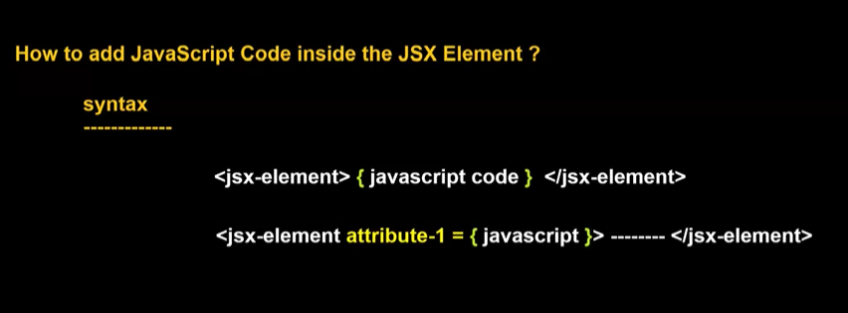

Therefore, you can use Javascript code inside JSX elements.This type of ability you don’t have in HTML.

Inside HTML code, you cannot write Javascript code.

To HTML attributes, you cannot assign Javascript elements or functions.

Where as to JSX attributes, you can assign Java script elements or functions.

To display cards in a single row, we have to use CSS.

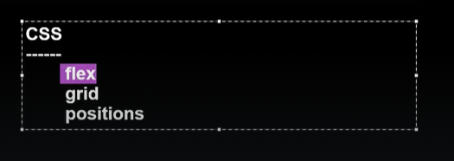

Direct child of a flex container are called Flex items.By default Flex items will display in row direction.

To generate equal space between all cards, we can use **justify-content:space-evenly**

**Study flex concept in CSS**

**How to pass different data in each card?**

One of the easiest way is we can use functions.

How to create UserInterface inside a Javascript function?

**SESSION-6**

**So far concepts learned**

**How to create simple card using JSX?**

**How to reuse UI?**

**How to create UI inside Javascript function?**

**How to pass dynamic data to UI?**

**<script type=”text/babel” ></script> ==here attribute -> type = “text/babel” indicates that we can write JSX code inside script tag**

**If you create your UI inside a Javascript function, then you have two benefits.**

1. **We can reuse our UI**
2. **We can pass dynamic data in our UI**

**Whenever you call the Javascript function, it returns the entire JSX code.**

**BLIND RULE:**

**In React whenever we want to create any UI, then we will always create that UI inside a Javascript function.Even if we want to create a simple button, we will create that button using JSX inside a Javascript function only**

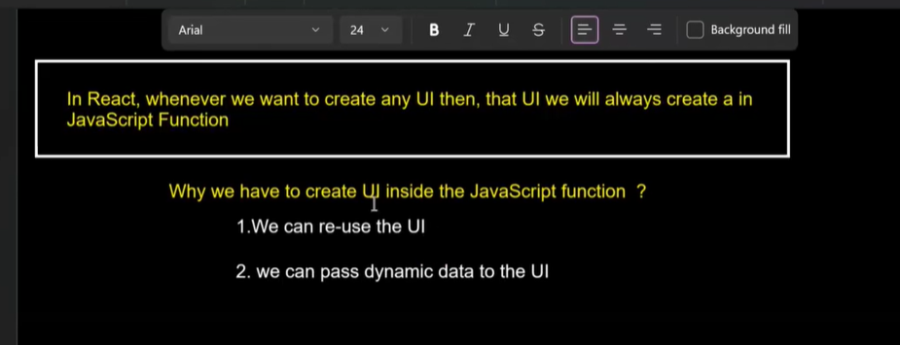

In Javascript, we call a function by using function name.

Ex:function createCard(){

return <div></div>

}

We call above function in Javascript by **createCard()**

**In React we call above function in element format i.e tag format**

**<createCard></createCard>**

**Or**

**<createCard/> ---self closing tag format**

**If you are calling your function in tag format in JSX code, no need to use curly braces inside the JSX elements.**

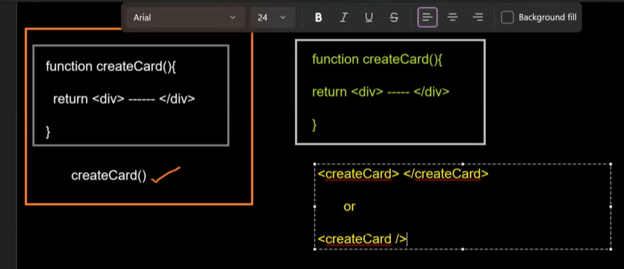

**If you want to call your function in tag format, then your function name should start with Upper case.While defining your function or calling your function the first letter should be capital letter**

**When we use certain libraries or frameworks, we need to follow their rules.**

**Libraries will have little bit of less rules compared to frameworks.**

**In Angular, we have lot of rules.If we use all those rules correctly, we will have a lot of advantages.Only problem is we have to remember all those rules.**

**What is Functional Component in React?**

**It is a simple JavaScript function whose name starts with uppercase and returns User Interface(JSX or React elements)**

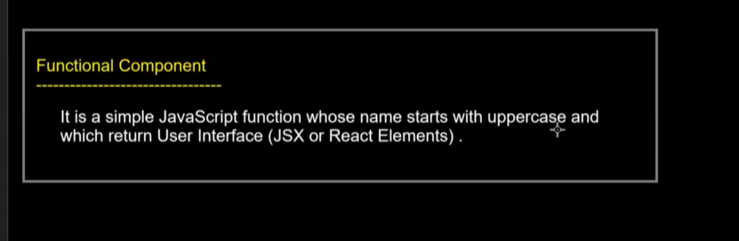

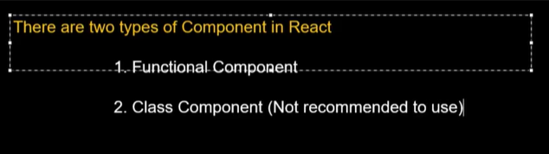

**No one in industry is uisng Class component.Everyone is using Functional component.React itslef recommend us to use Functional component and not Class component.**

**New documentation of React is completely created on Functional component.**

**In Angular also we use a lot of Object Oriented Programming(classes).Slowly they are moving from Object Oriented Programming to Functional Programming.**

**The core reason for moving towards Functional Programming is its simple to create and fast in execution**

**Before 2018, in React everybody was using Class component.After 2018, everybody started using Functional Component**

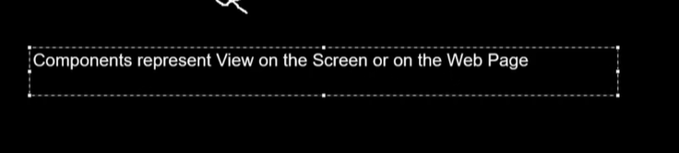

One Web page can have any number of components.

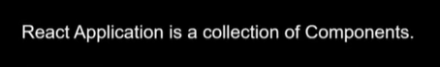

Therefore React and Angular follows Component based architecture

Concepts learned so far..

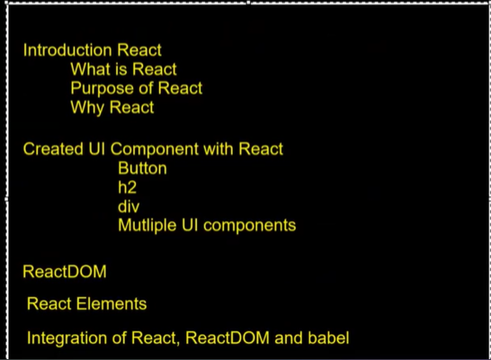

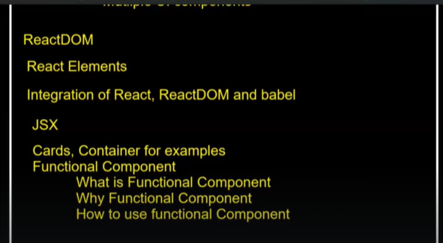

**SESSION-7**

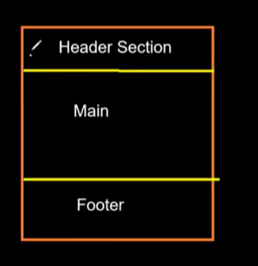

To create three sections as above in React, for every section we create a Component.We can do it by creating one component also.But in future we wont be able to reuse Header section ad footer section.

So as per react, we have to divide our User Interface into smaller components as much as possible so that we can reuse those components whenever and wherever we need them.

**How to link CSS file with HTML document?**

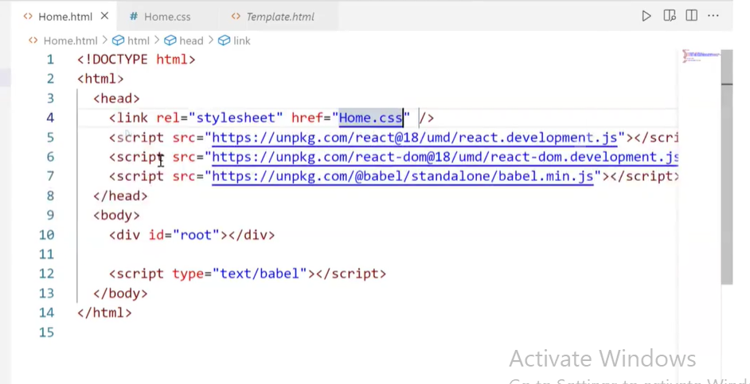

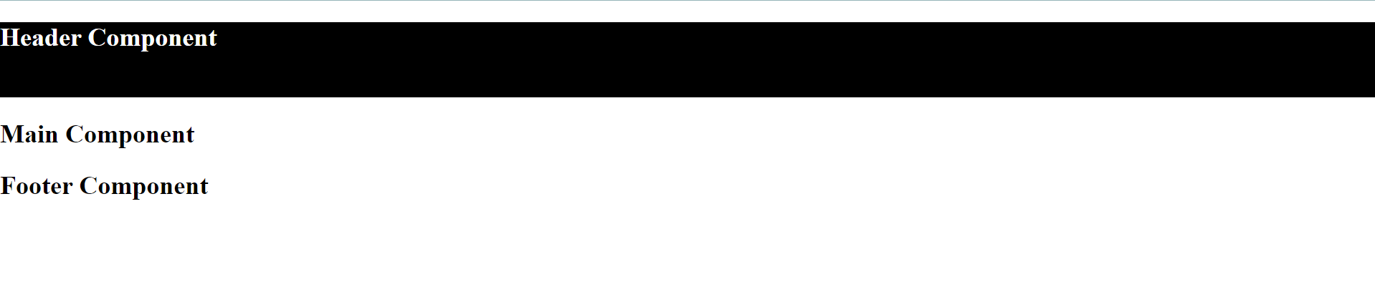

When you want to remove extra spaces , you need to give margin 0.

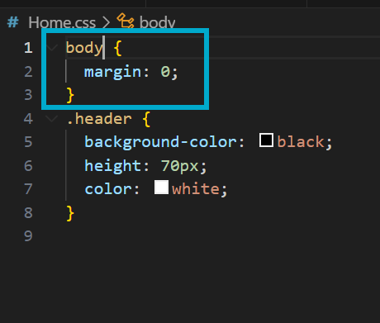

If you want to remove extra spaces for all components, you need to give **\***

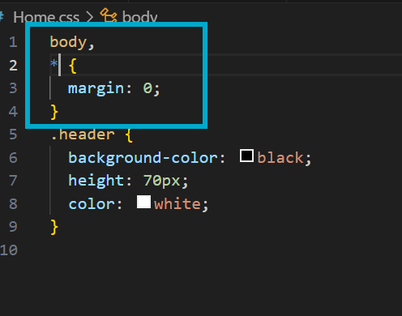

Output looks like below

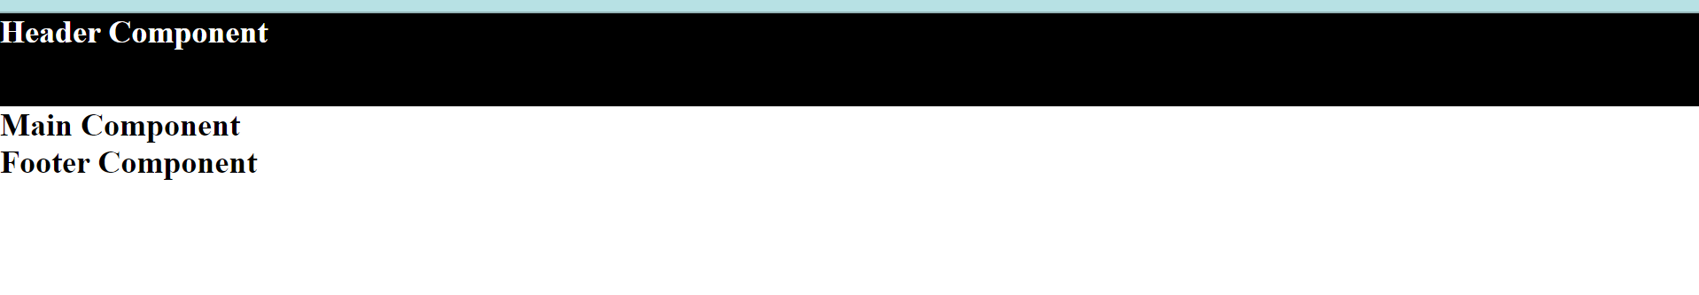

FLEX concept is very important

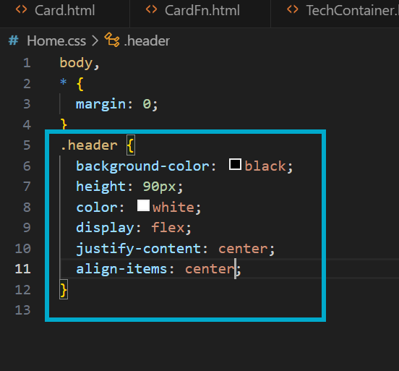

Without adding display:flex, justify-content and align-items don’t work.

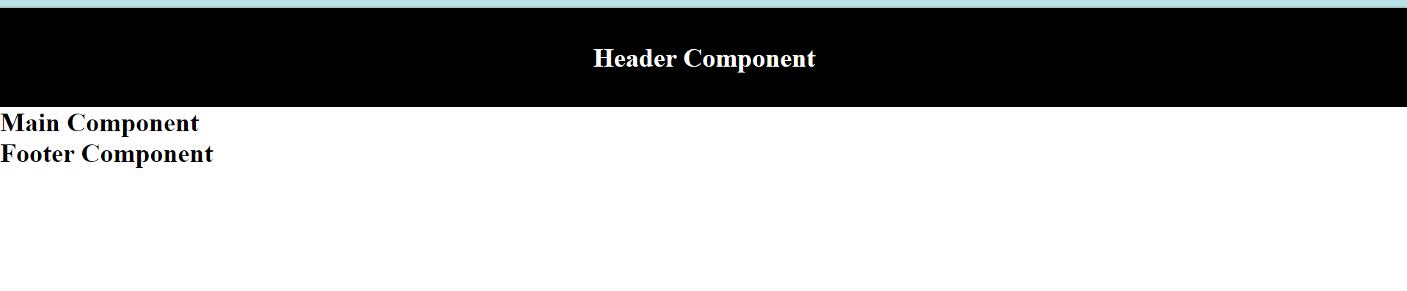

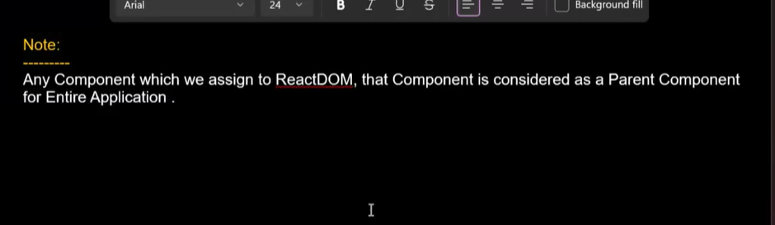

**Rendering = calling --- calls+converting JSX elements into React elements + added in the DOM**

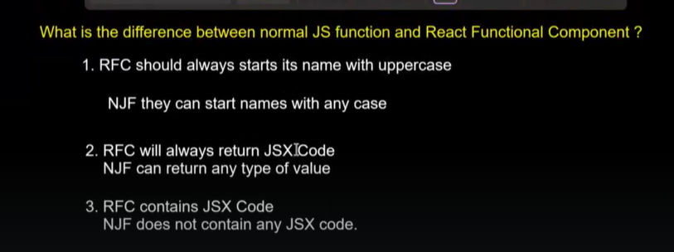

When you are using Java script functions we can use the term “call”

When you are using React Functional components, we can use the term “Render”

**If the component is a class, then for styling in CSS you have to use .class name.**

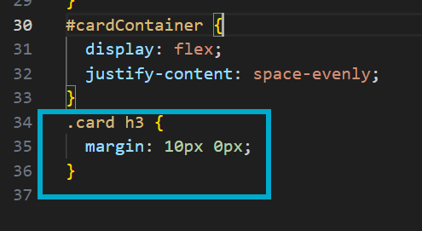

How to pass dynamic data to your component if you are calling in the element format?

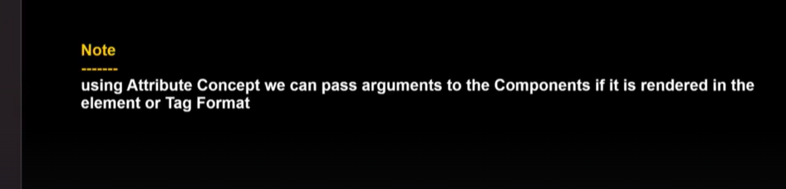

In normal HTML, we call it as Attributes.In React we call it as Props.

The first parameter inside the Functional component is always the Object and inside this object your Props will be stored.(Props will be stored like properties inside the object)

People prefer to keep the name of the first Parameter as Props